Name: Mriganka Patra

Email: [mriganka.patra@cognizant.com](mailto:mriganka.patra@cognizant.com)

Emp ID: 2415820

Day 18

Sprint 1 Submission

Objective: Implement the base CRM logic with record types, automation, visibility settings, and user management.

Task 1.8: As a System, I want to update fields based on predefined conditions to ensure data consistency.

1. Go to setup page > Home > workflow rules

4. 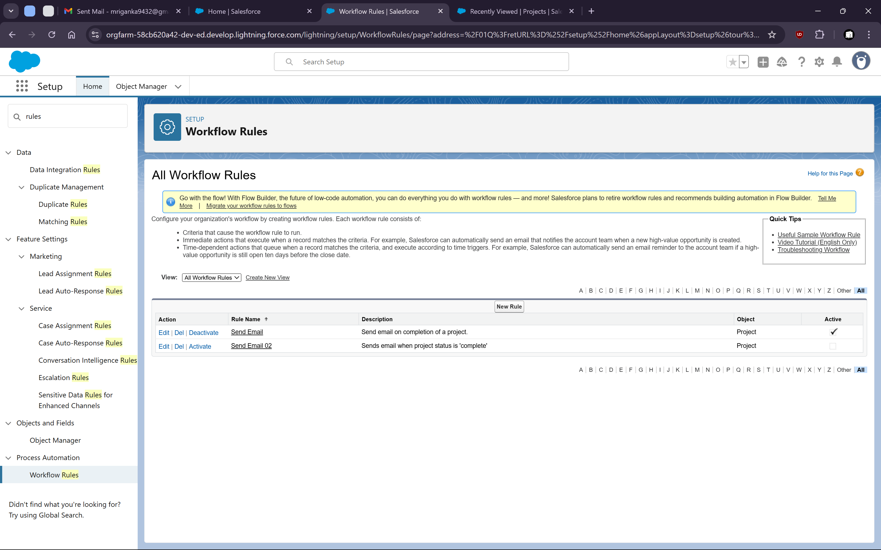

7. Create Rule with Project Object


11. 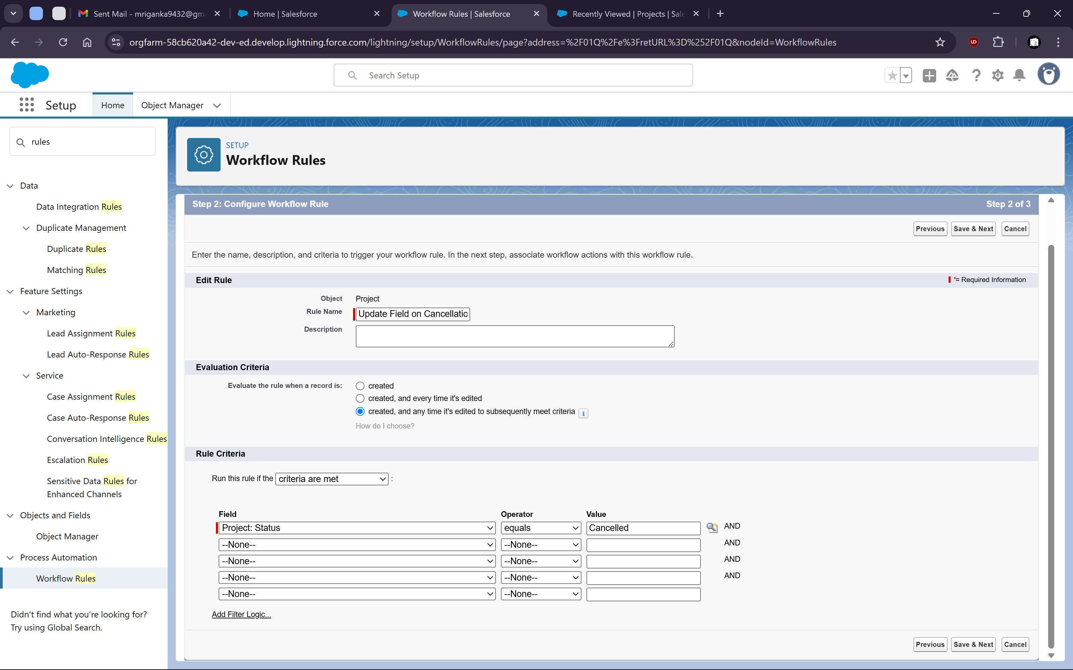

14. Setup Blank Value if Project Is Cancelled


18. 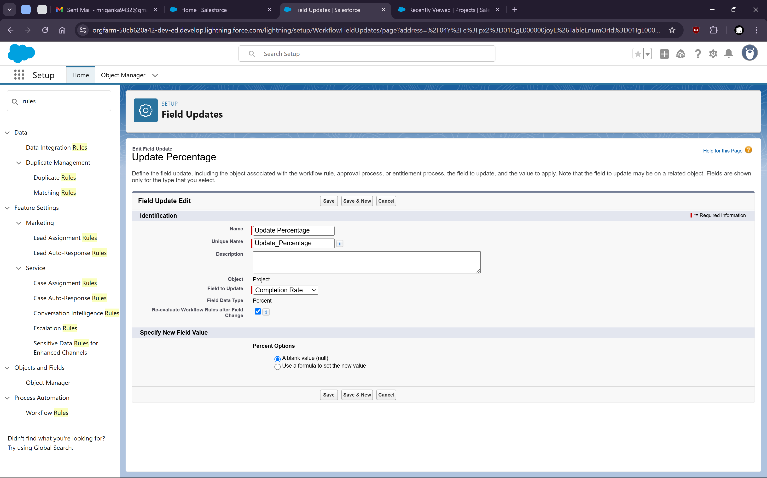

xiv. Now Activate the rule

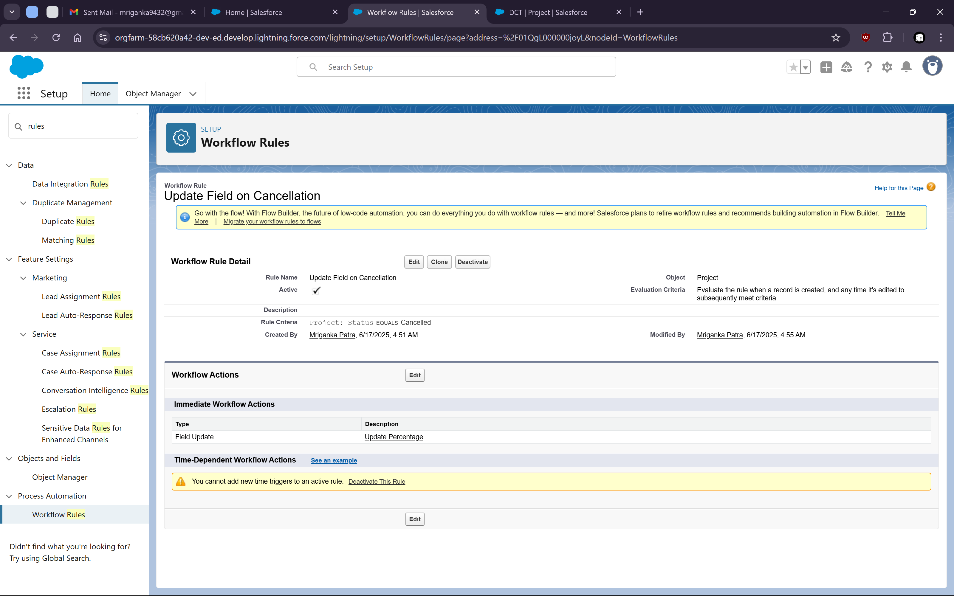

Xv. Now check if the rule is working or not

Go to one of the project where status is anything other than cancelled and the progress has a value

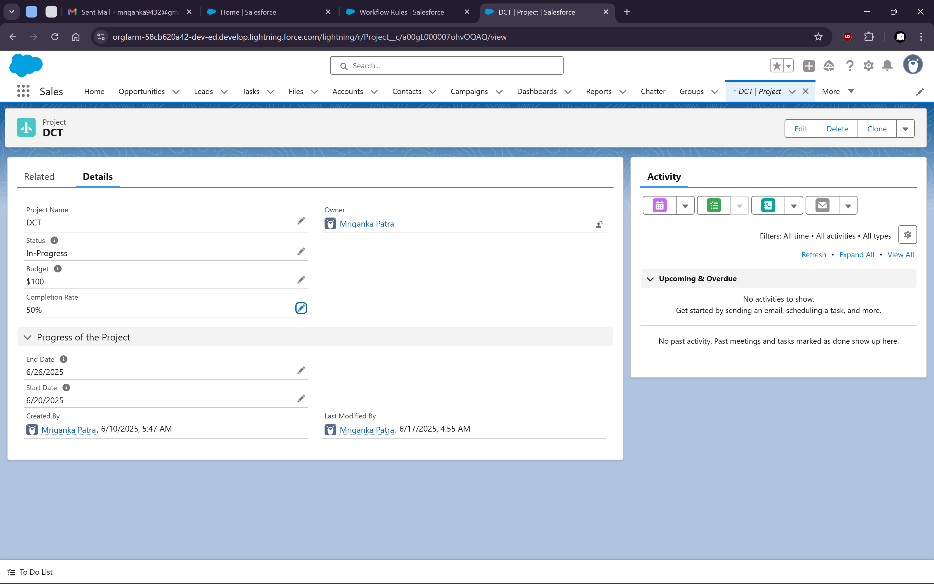

Now change the status to “Cancelled” and save it

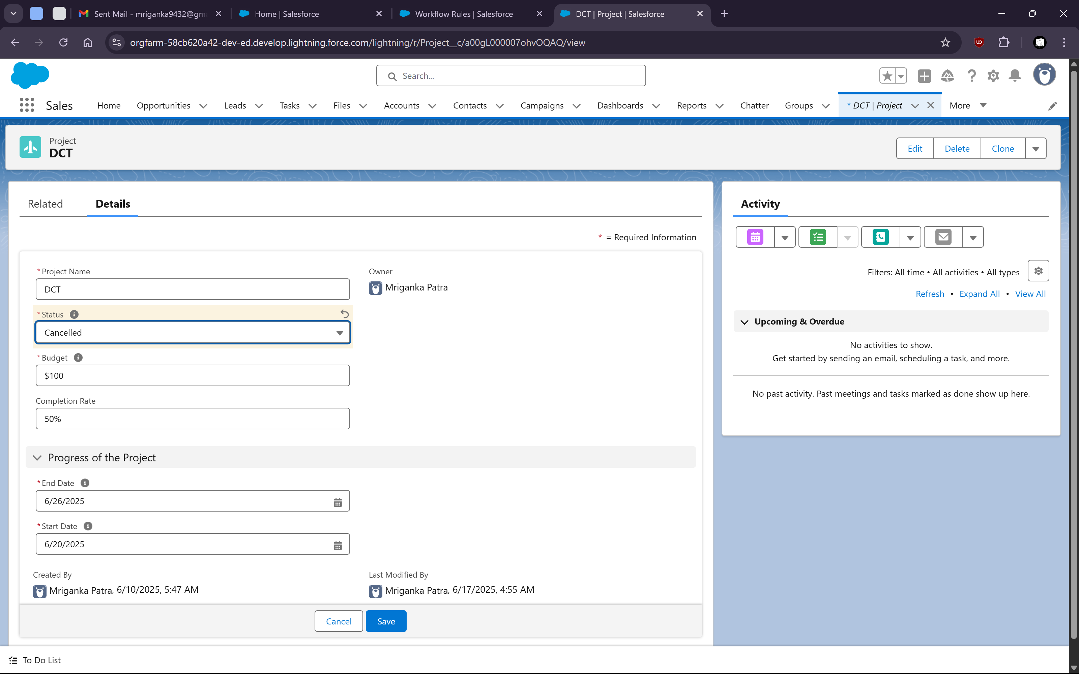

We can check that the completion rate gets set to NULL value after that

